Simple Project with Node and Express

Create a project file

1. app.js

2. write npm init for create package.json files

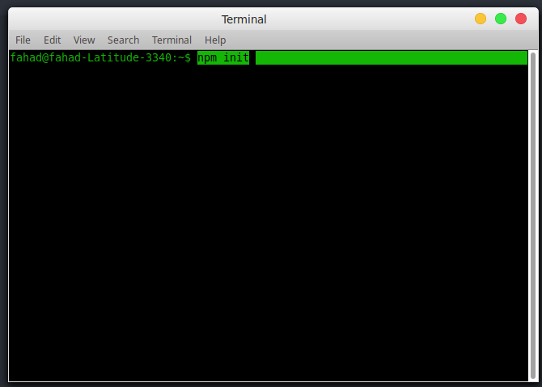

after npm init created package.json file

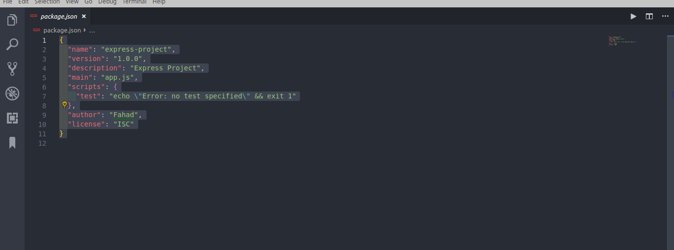
What is Express ?

Express.js, or simply Express, is a web application framework for Node.js, released as free and open-source software under the MIT License. It is designed for building web applications and APIs. It has been called the defacto standard server framework for Node.js.

Now Install express using this command:
npm install express --save

run command in terminal or git bash here or window cmd .

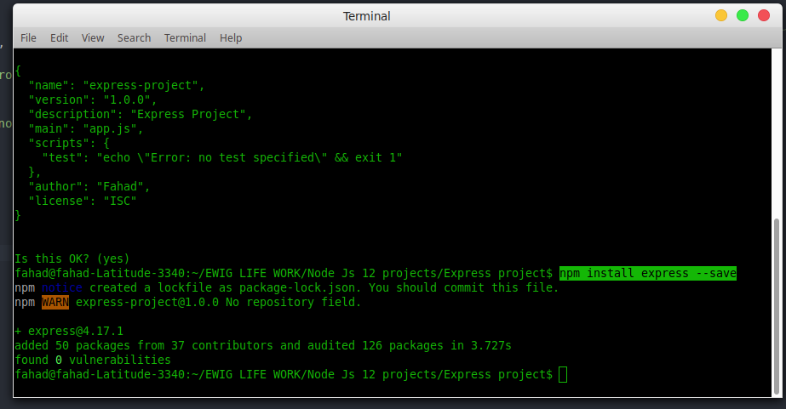

After installing the express check the package.json file dependencies . Express save or not ? And also auto install node_modules and package-lock.json files when we install express.

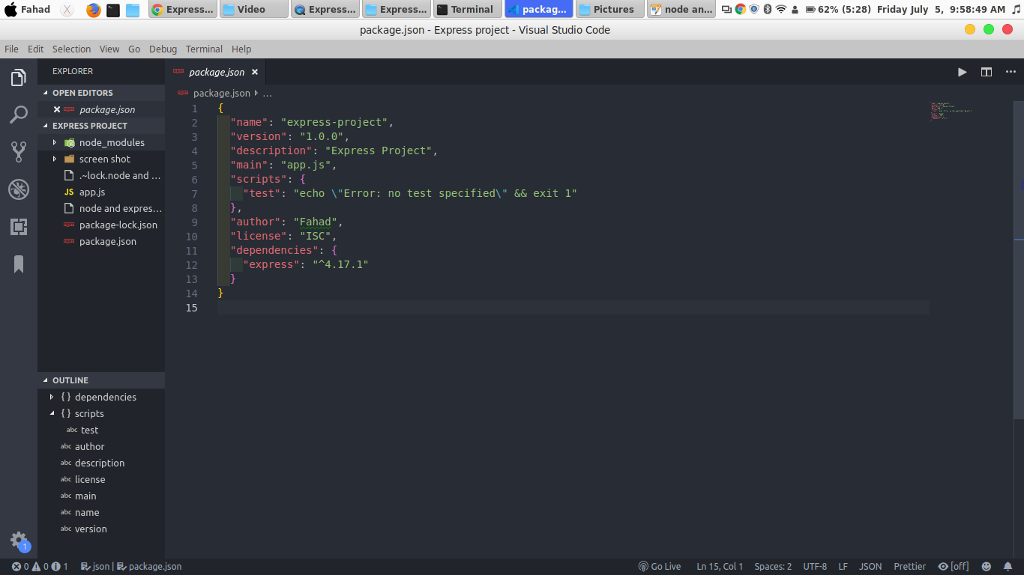

Express installed.

Now install body-parser , nodemailer , jade using these commands

npm install body-parser --save
npm install nodemailer --save
npm install jade --save

After install check the dependencies.

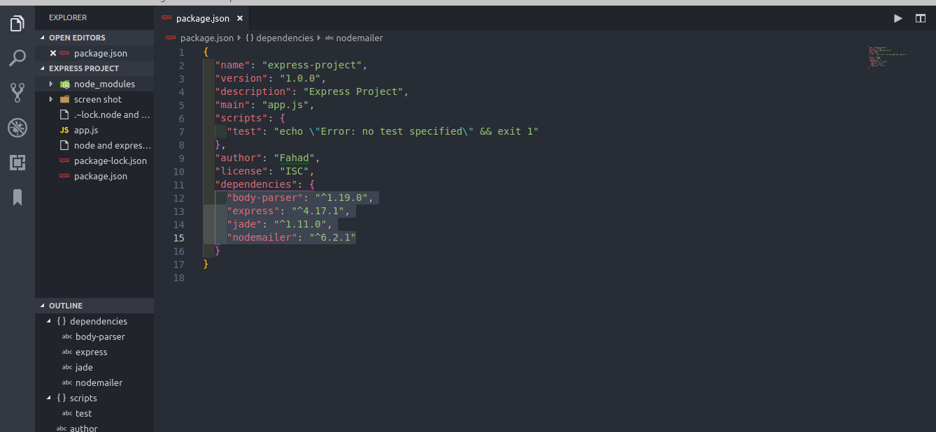
Now write a code in app.js file.

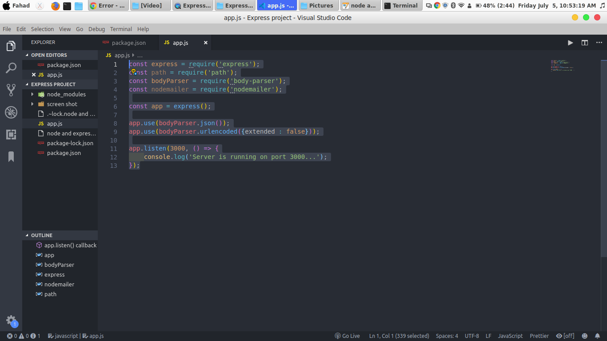
Output:

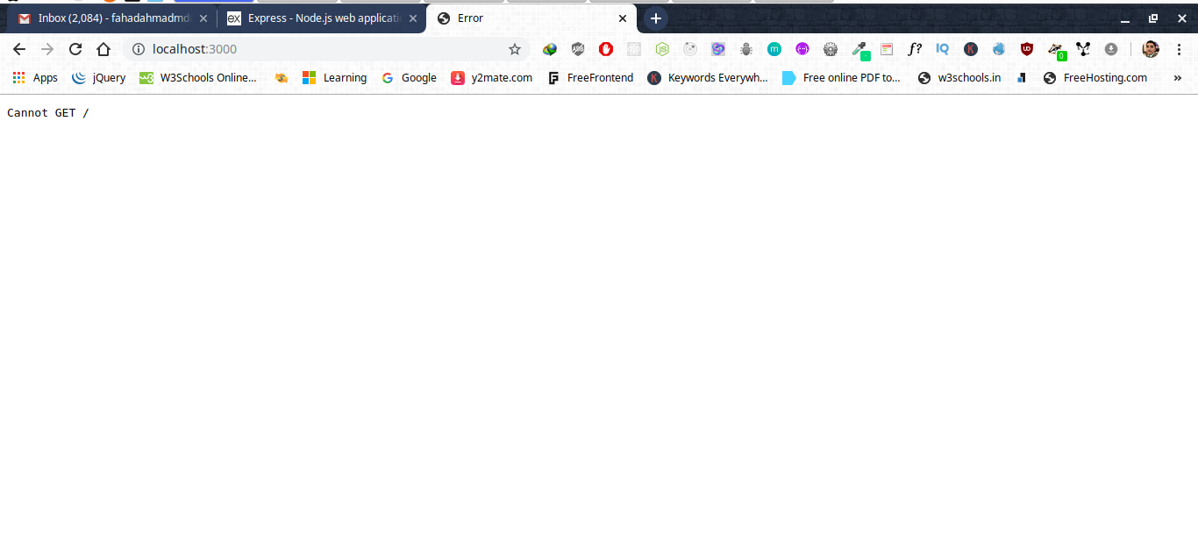
server is running successfully.

After running the server show the Get / error .

write the get function
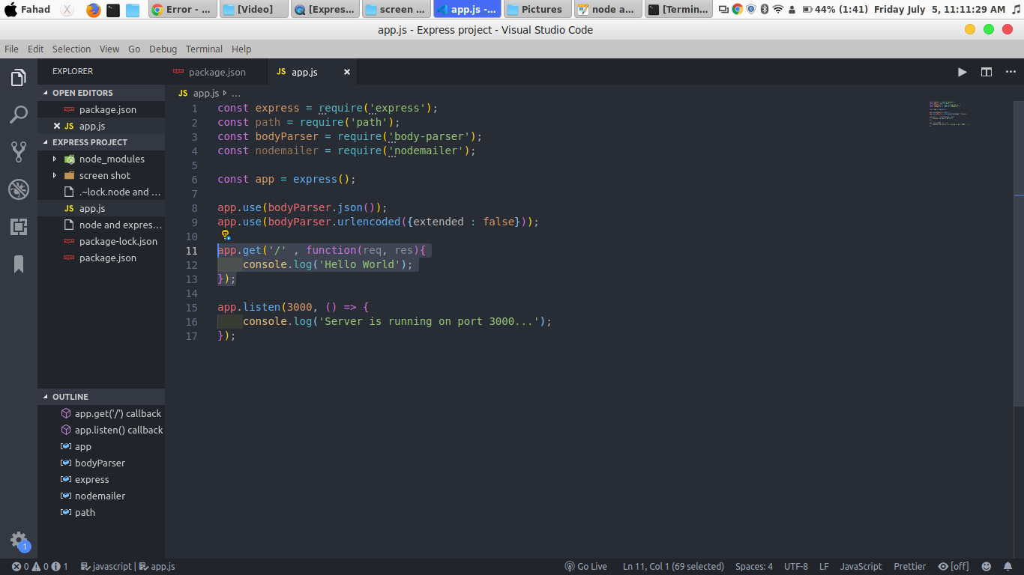

Output:

show output in terminal or cmd.
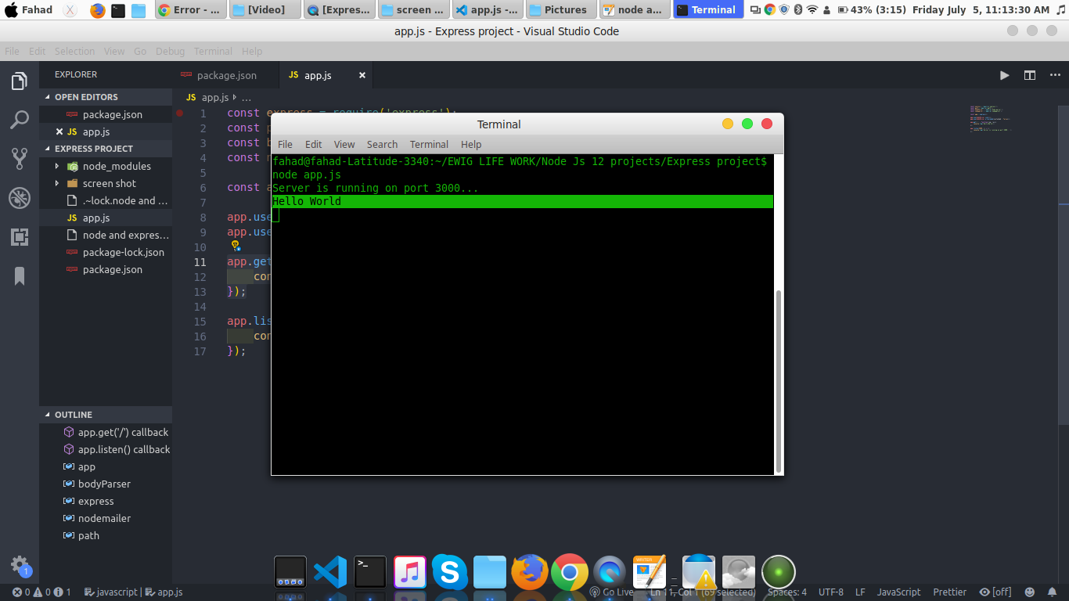

Output show in console but not show in browser. Now write a code to show output in browser.

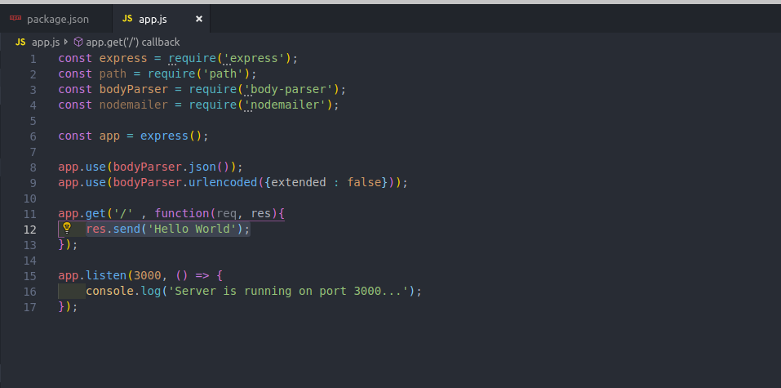

Output:

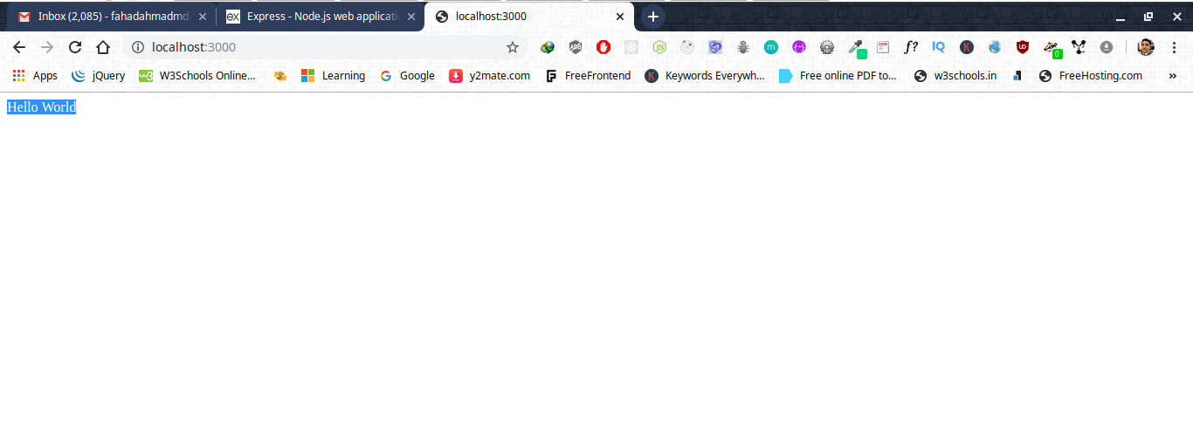

now add set views

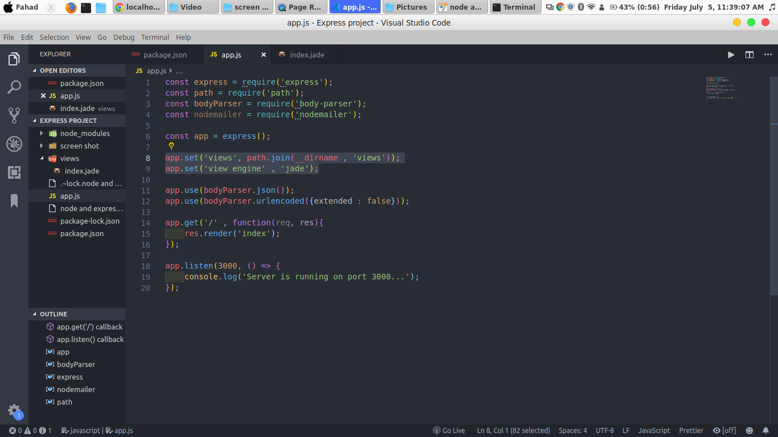
replace res.render(‘index’); in line 15

create views folder and create index.jade file inside views folder.

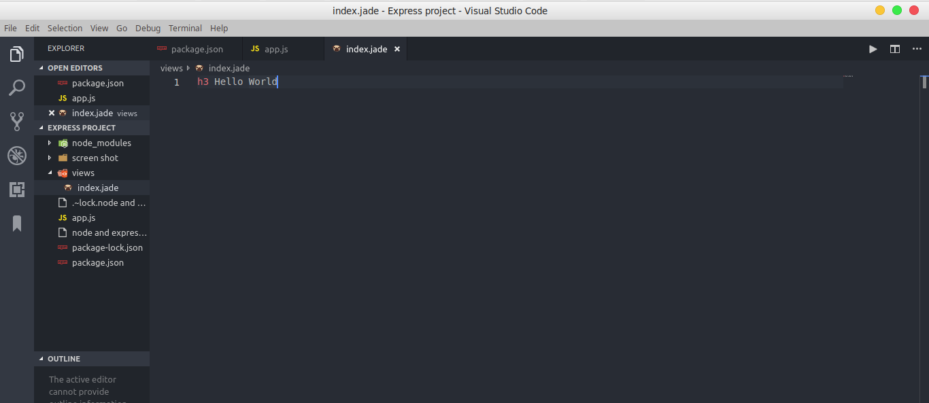

Output:

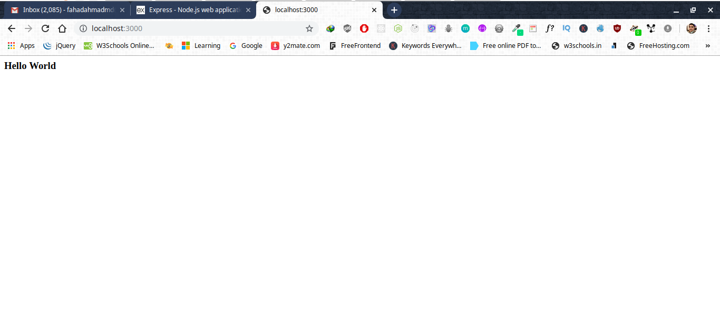

Add new layout.jade file
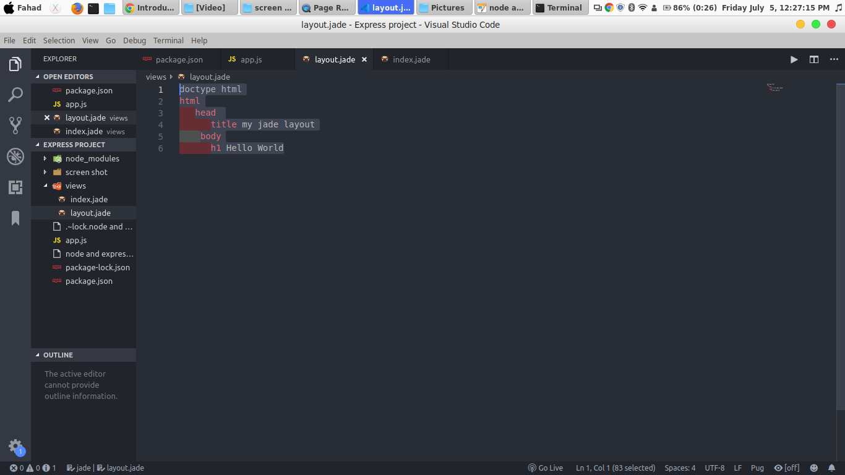

connect to index.jade file

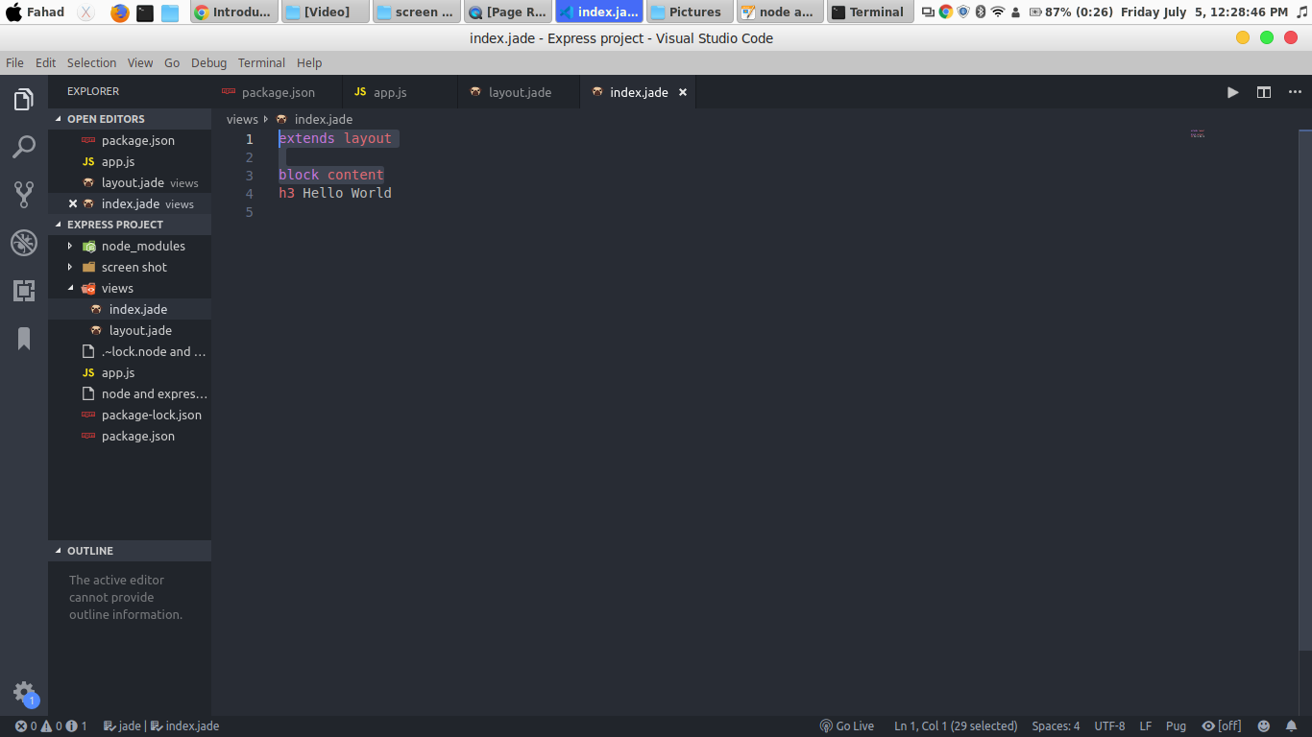

Output:

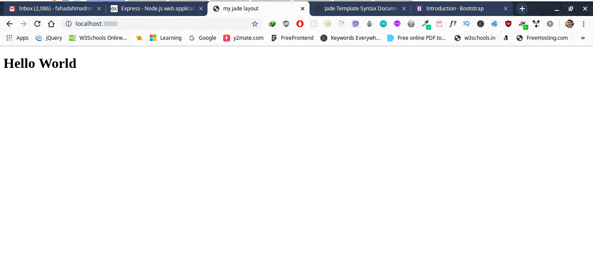
rightClick on the Browser and check the source code.

Browser convert all the jade code in html form.

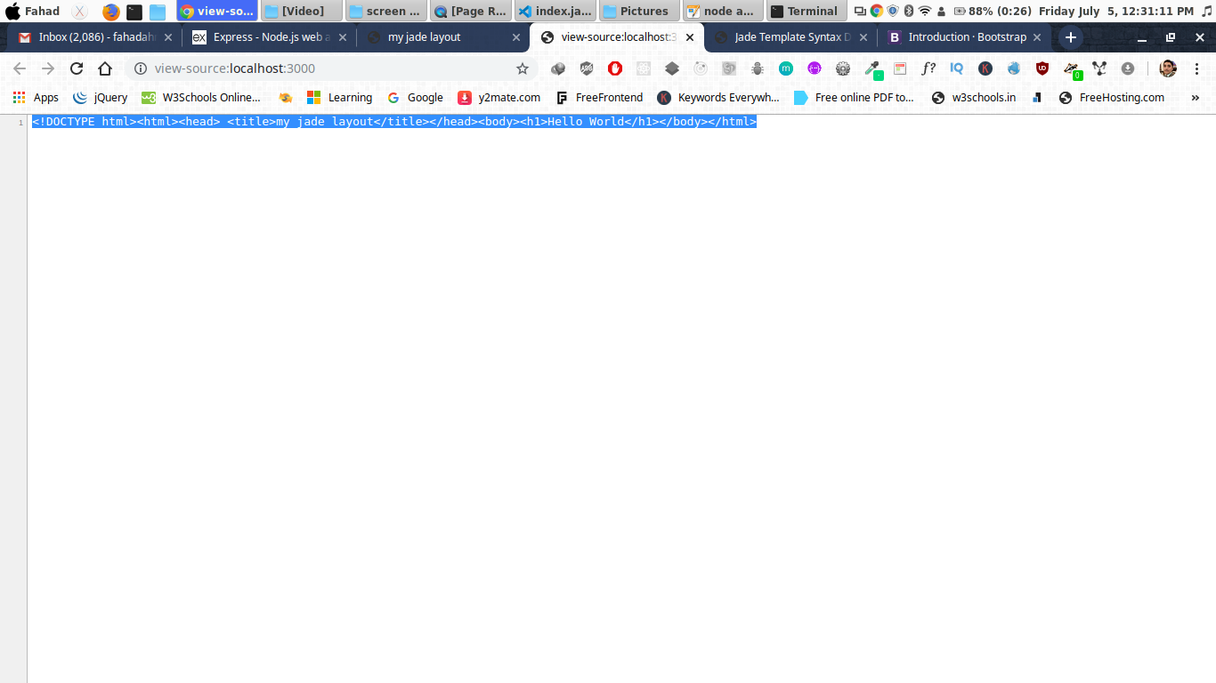

Now create bootstrap layout.

Download bootstrap

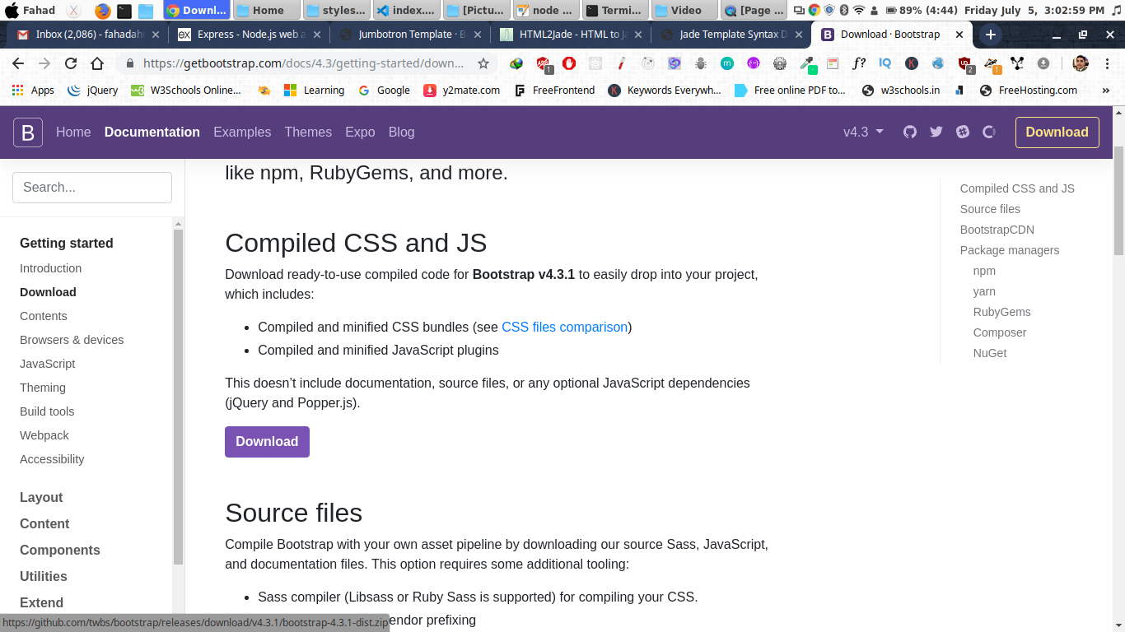

after download link bootstrap.css in html file

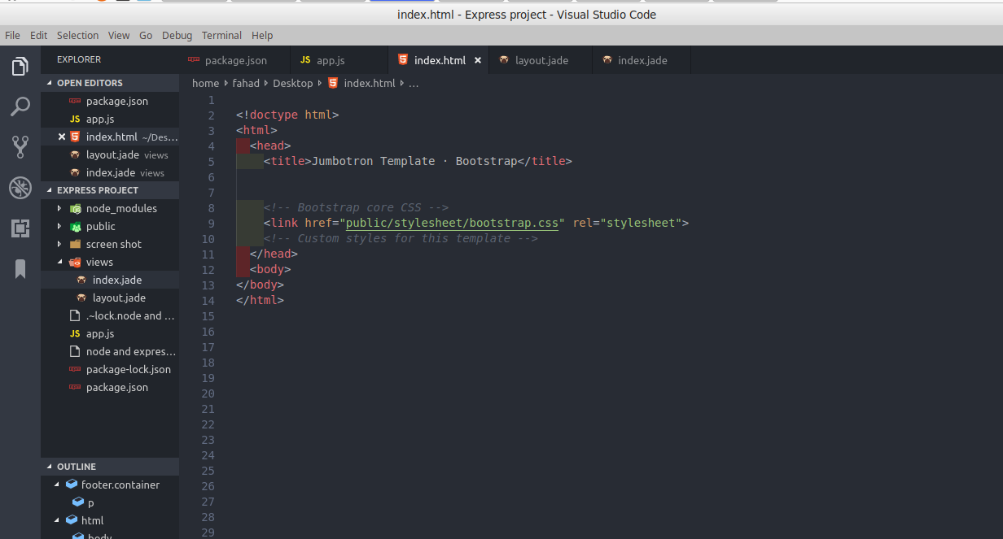

now create nav

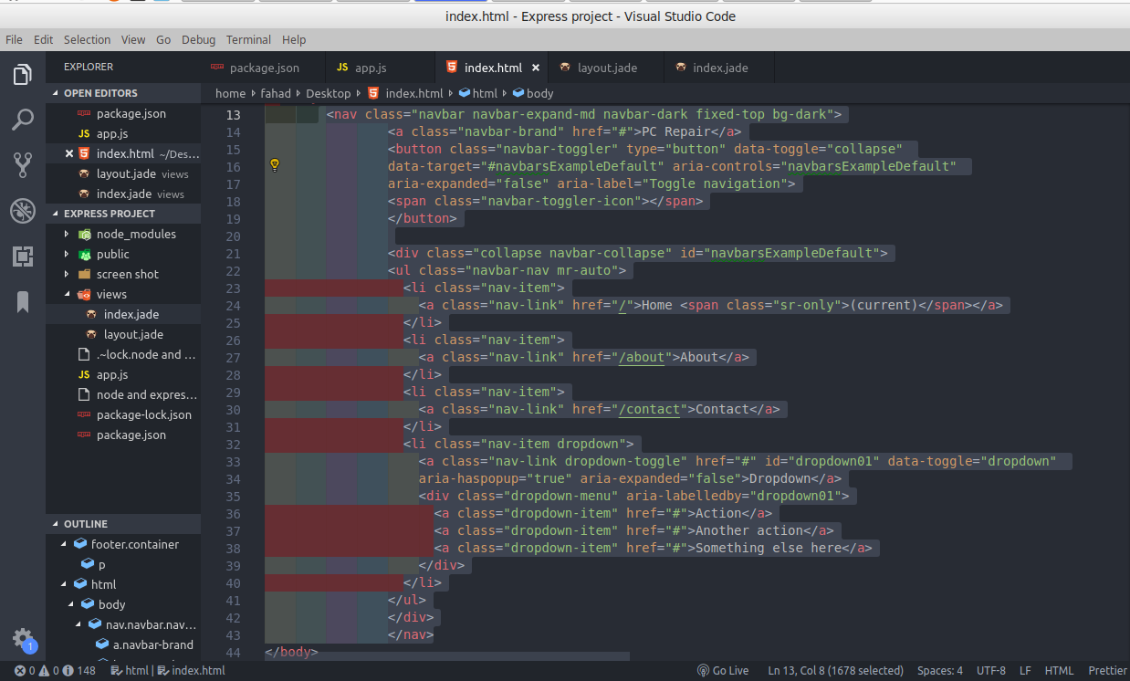

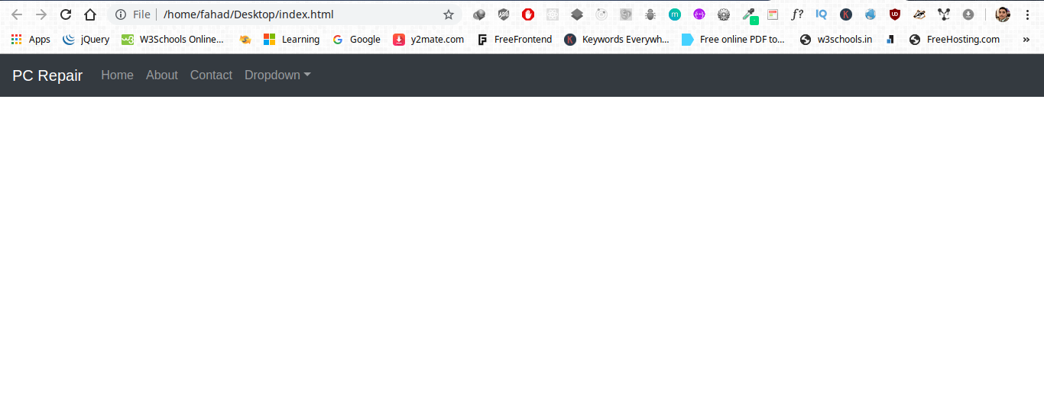
Output:

Now add header section

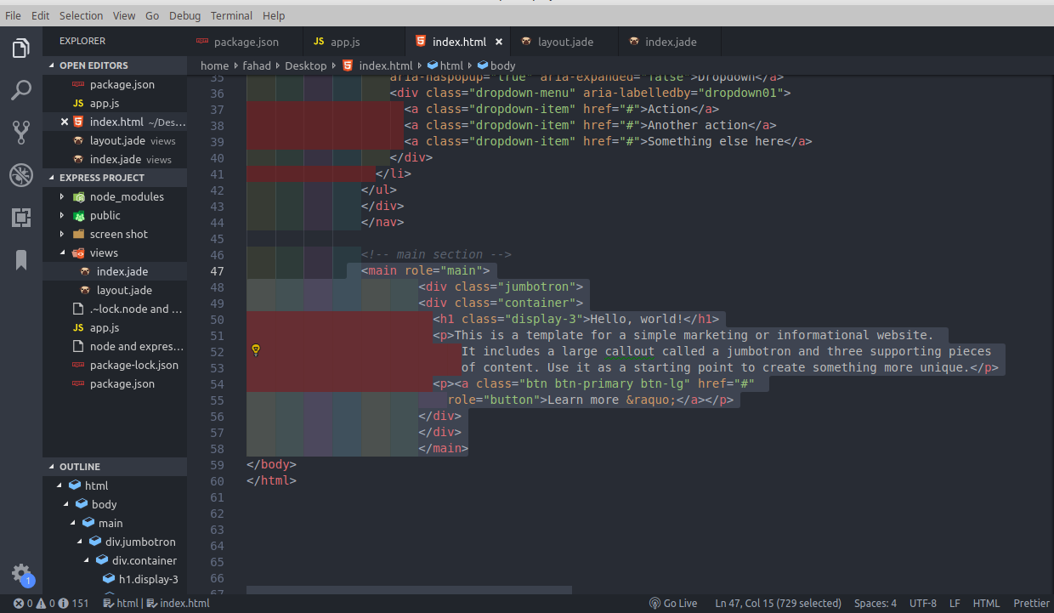
Output:

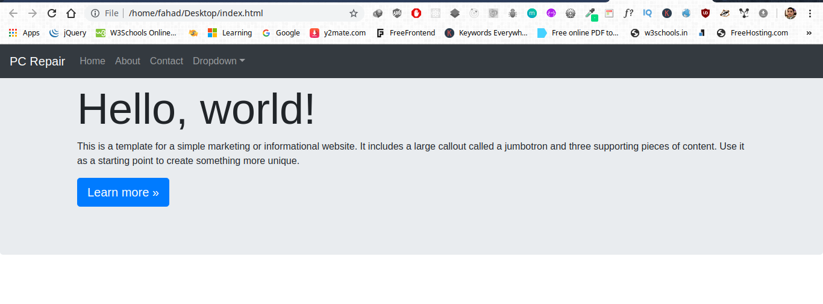

Now add detail section

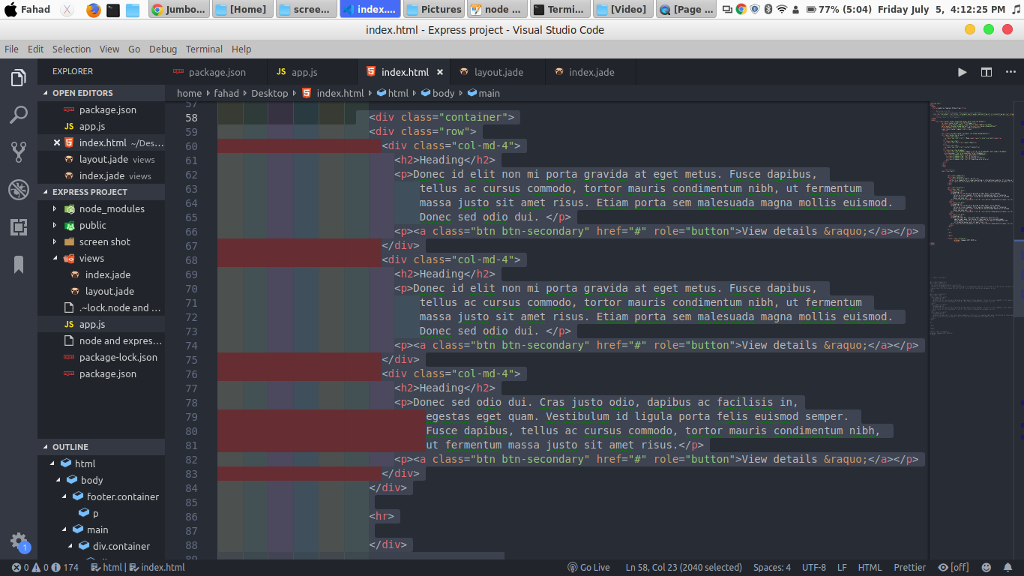

Output:

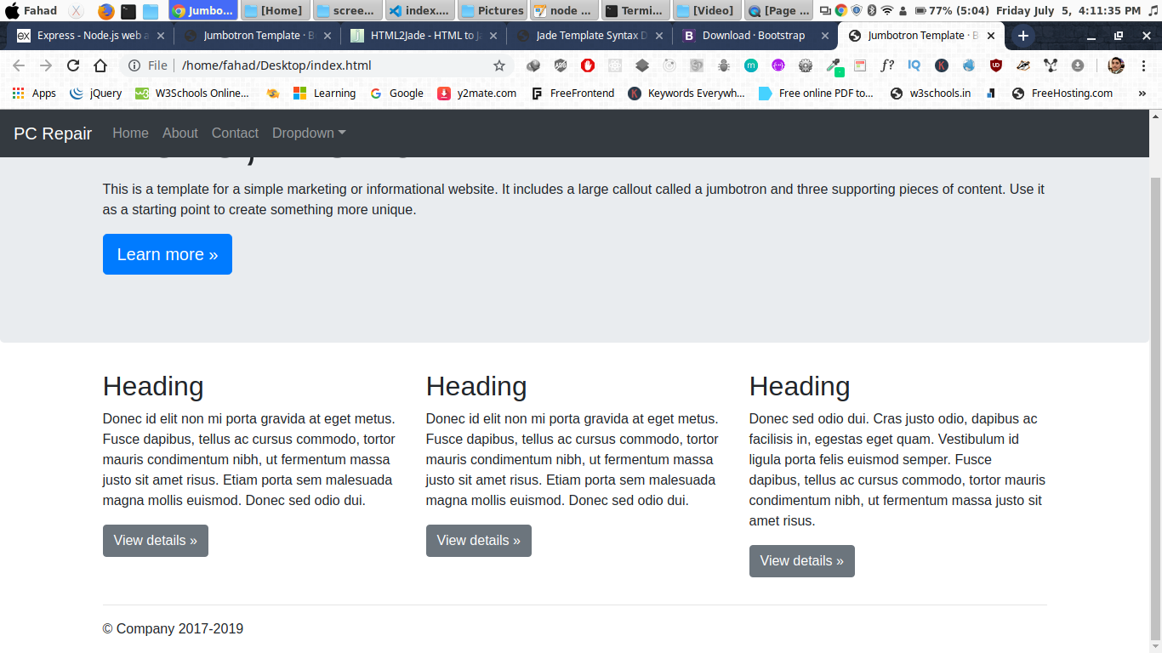

Now convert code in jade. Using the jade converter .

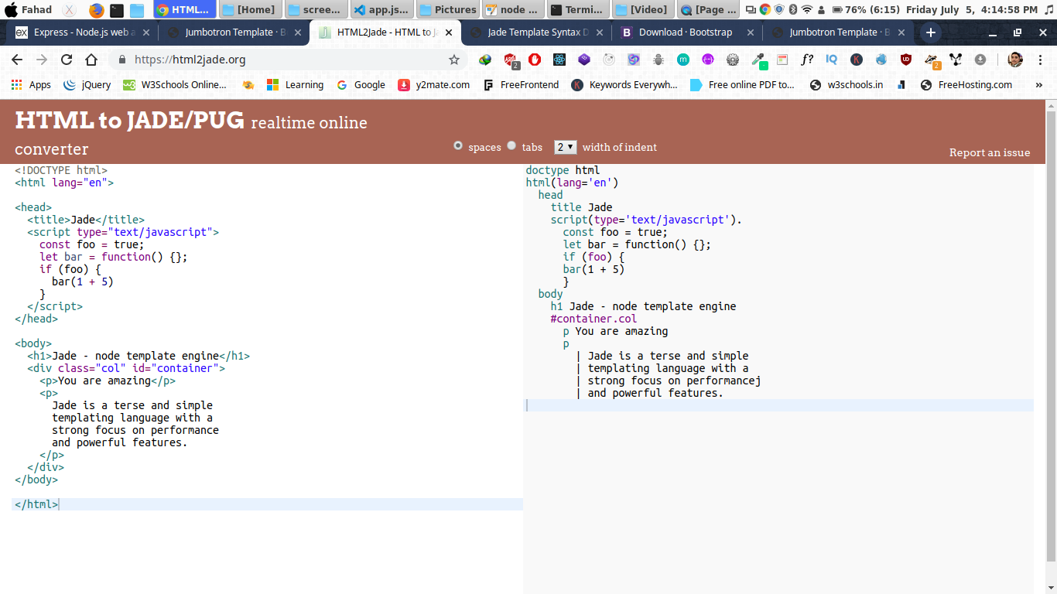
copy the html code and past here

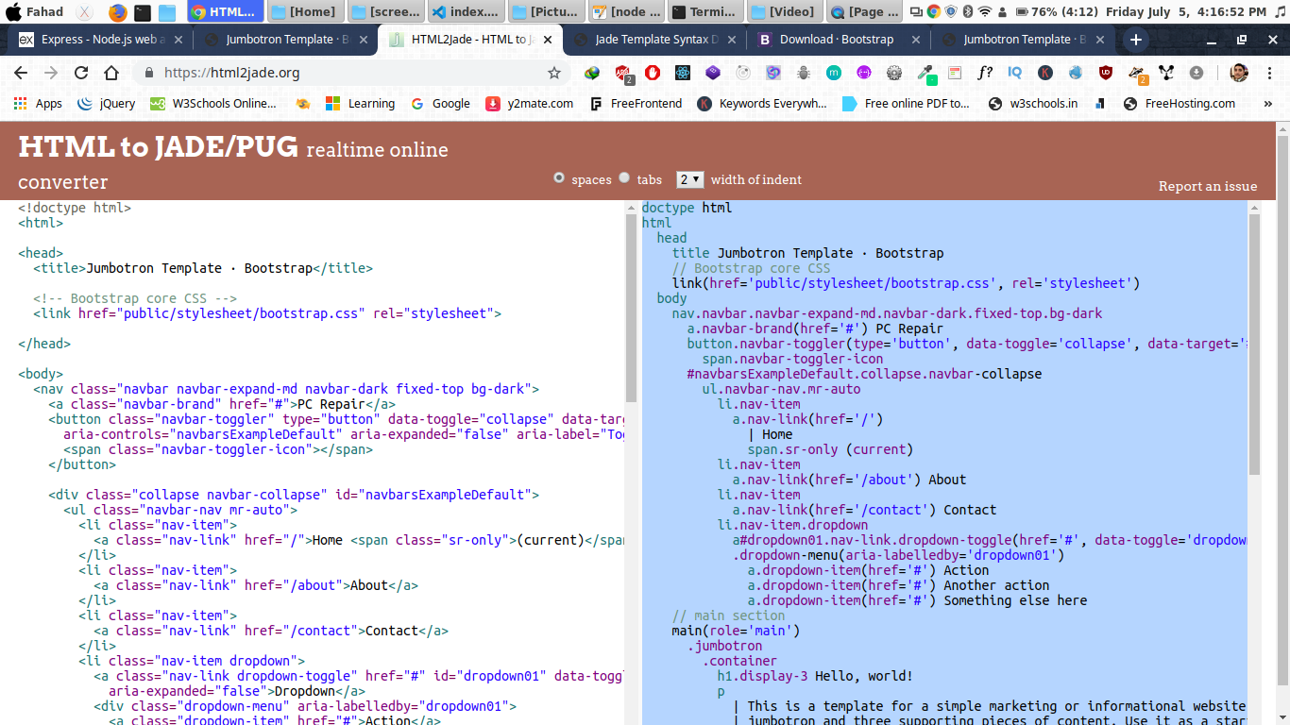

copy the jade code and past in layout.jade file

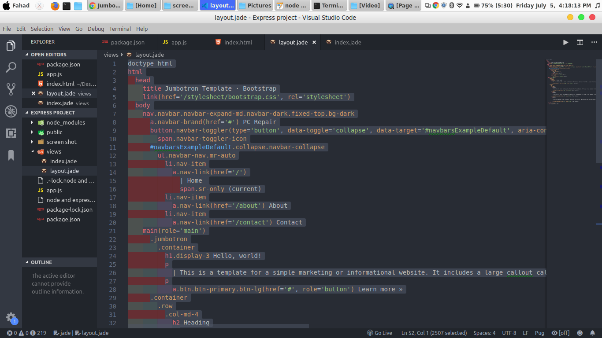

now copy the main section and past in index.jade file but don’t forget to use block content before footer.
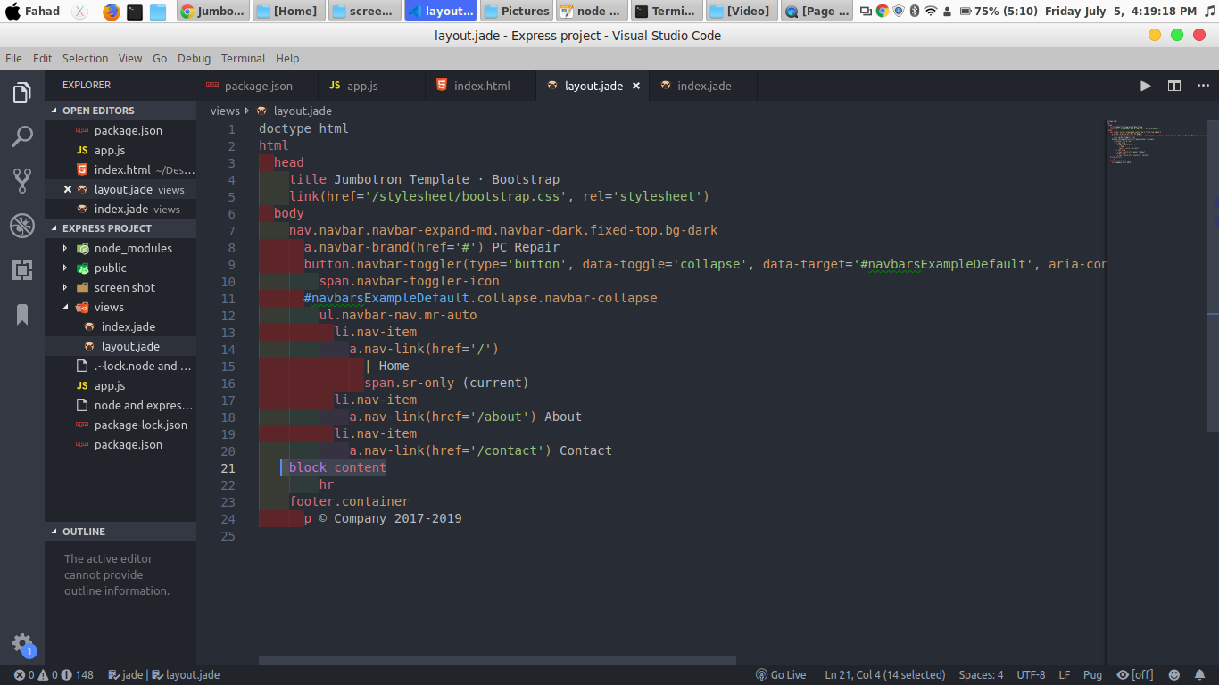

index.jade file

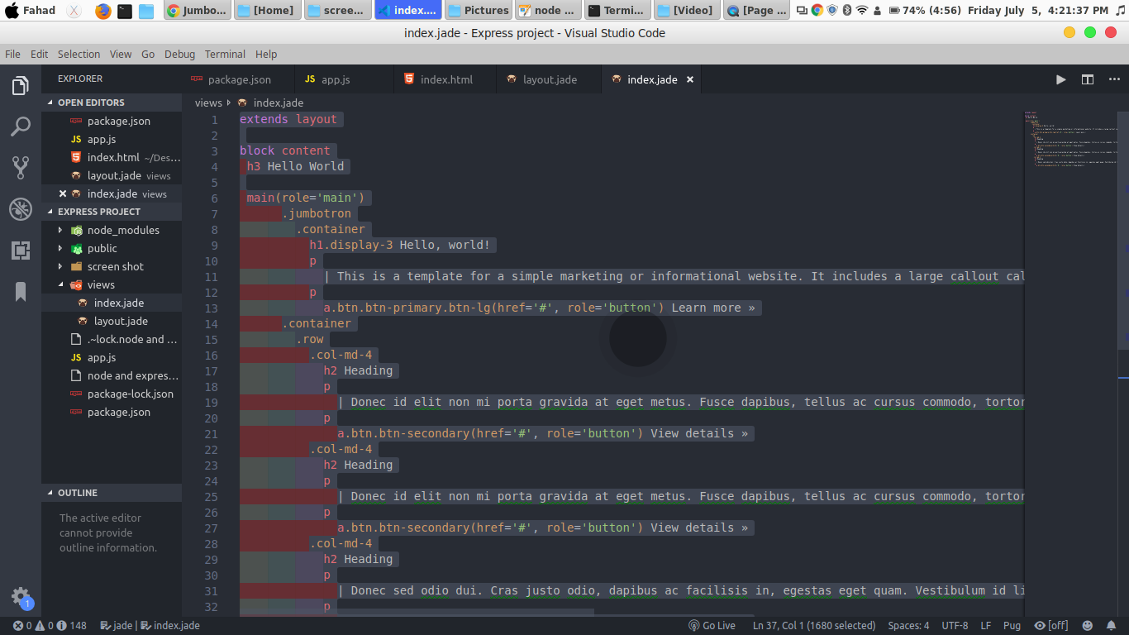

code indentation is most important.

Refresh the node server. Using node app.js command

Output:

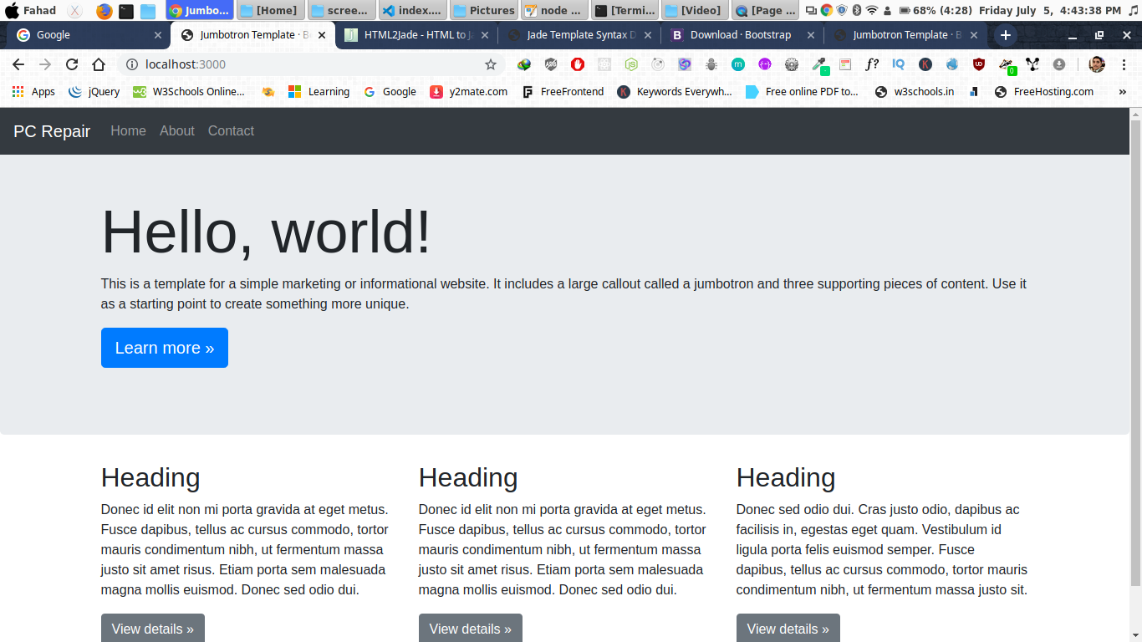

now create about section

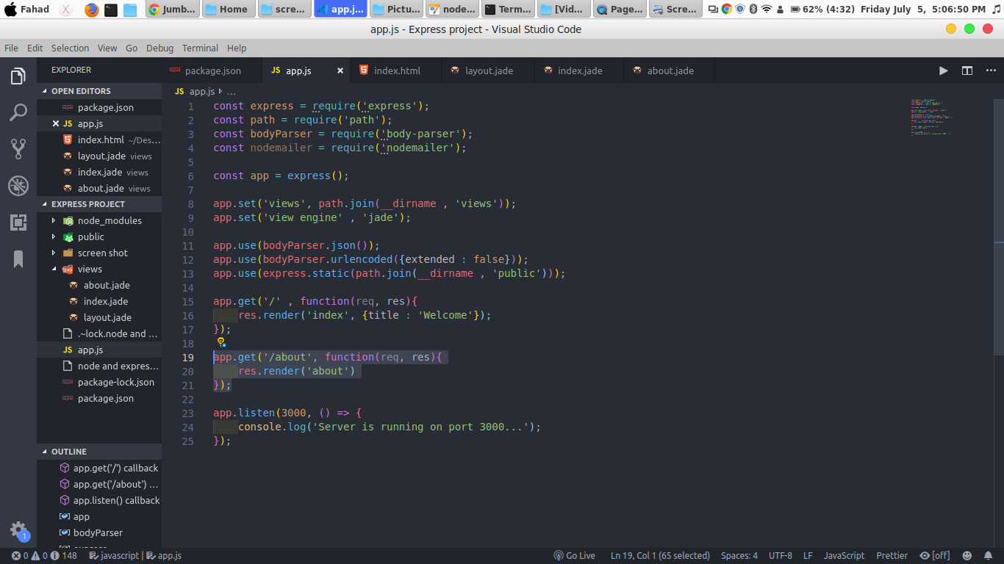

create about.jade file

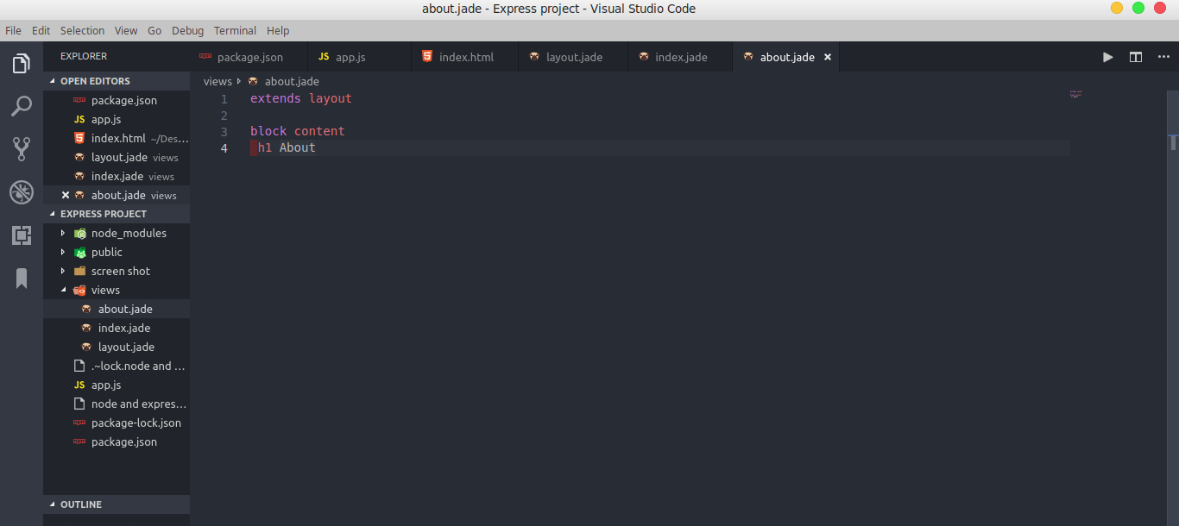
run server and check output:

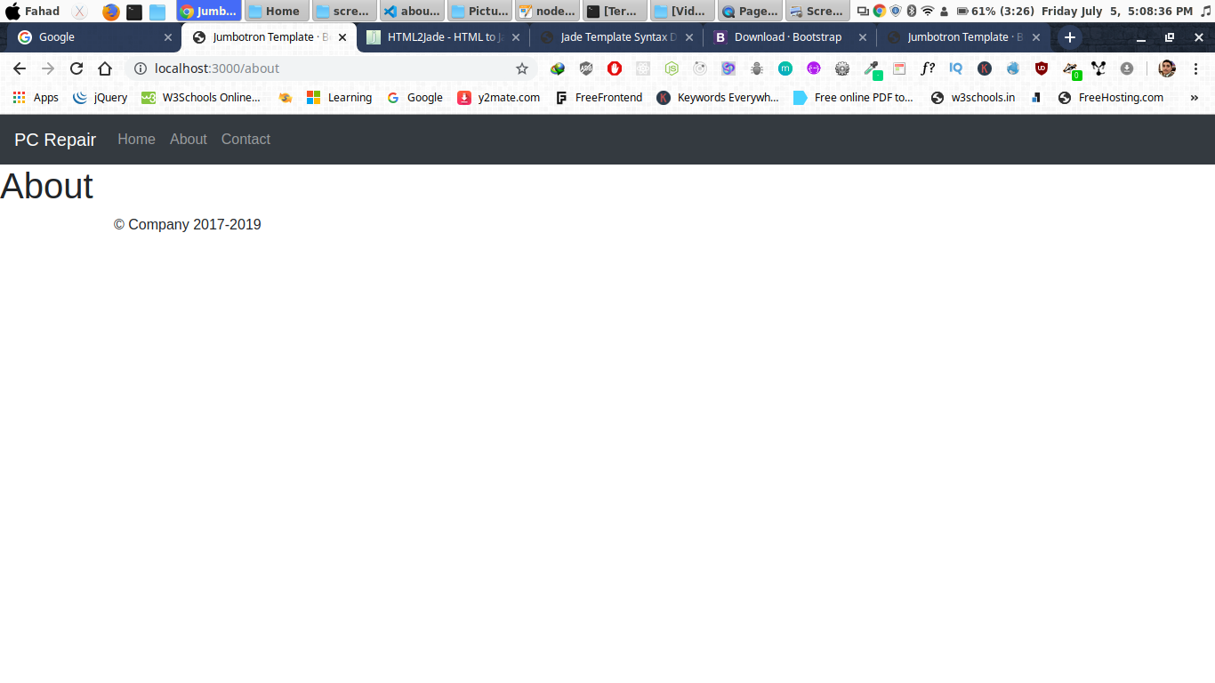

Now add paragraph

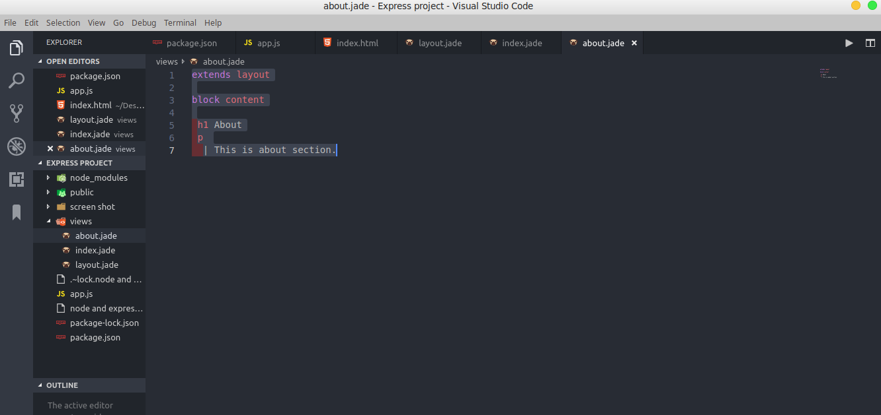
Output:

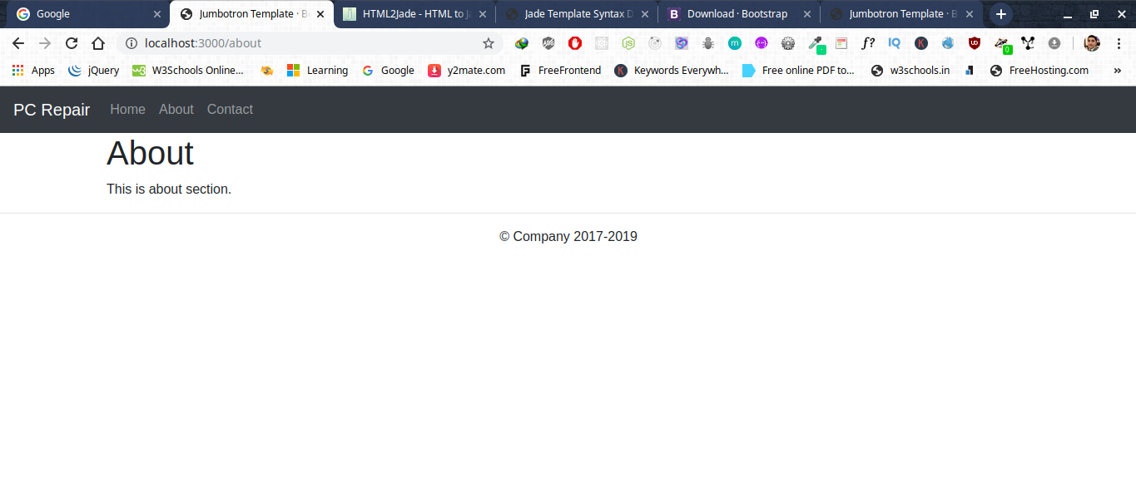
Now create contact.html file.

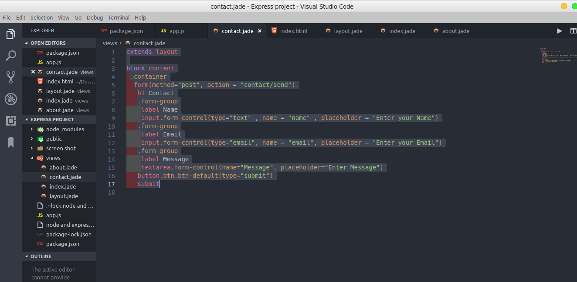
Output:

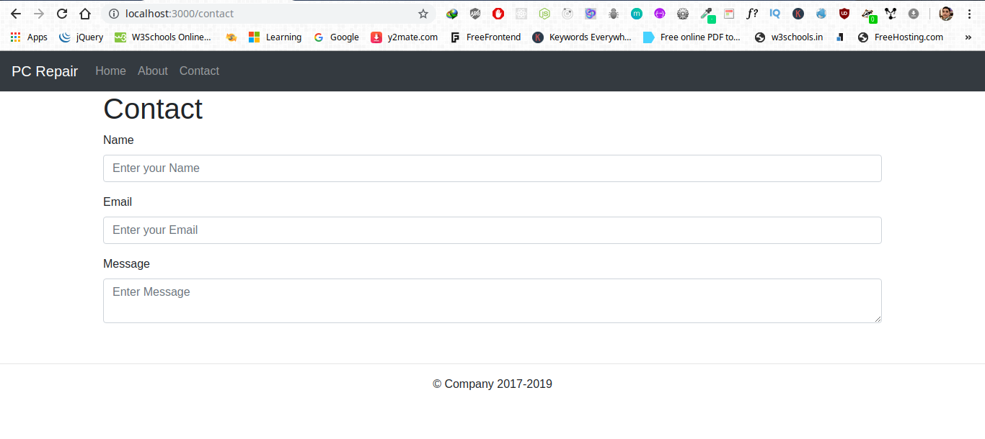

Submit button not show

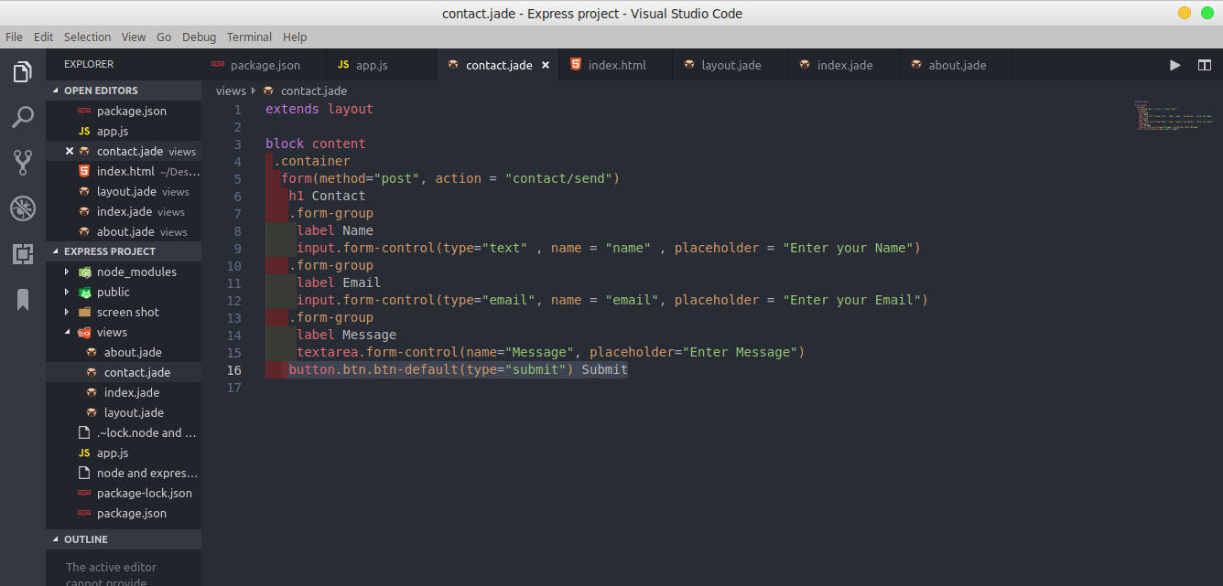
Output:

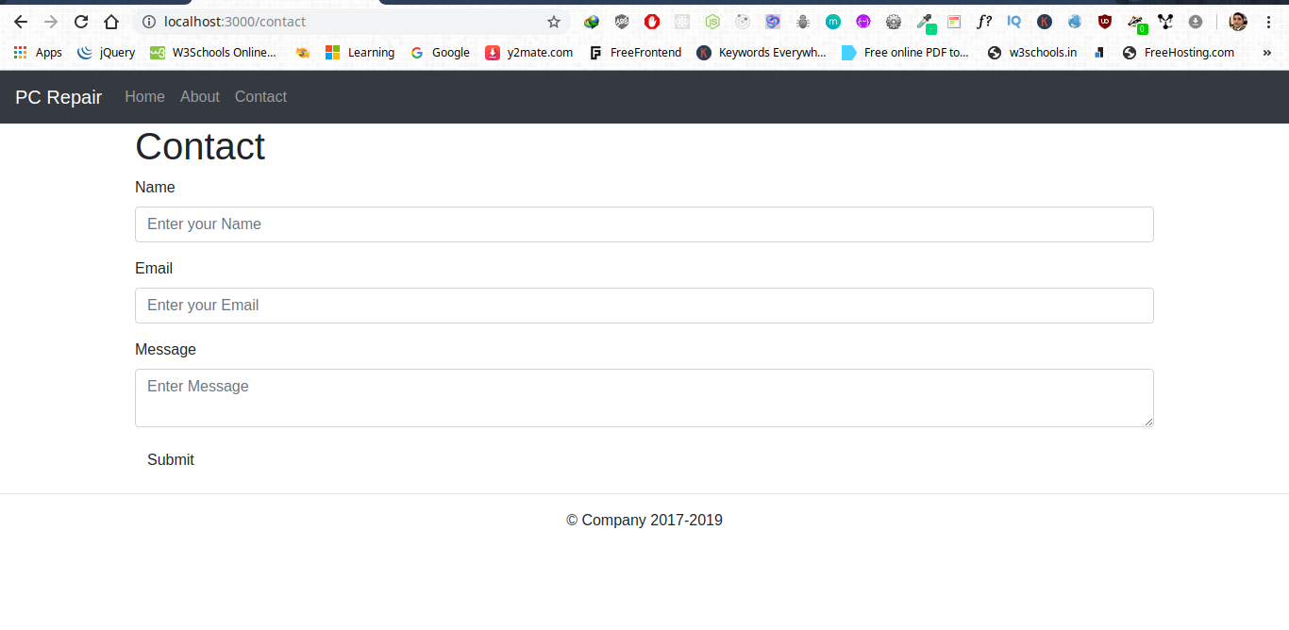
Now add post method on submit button.

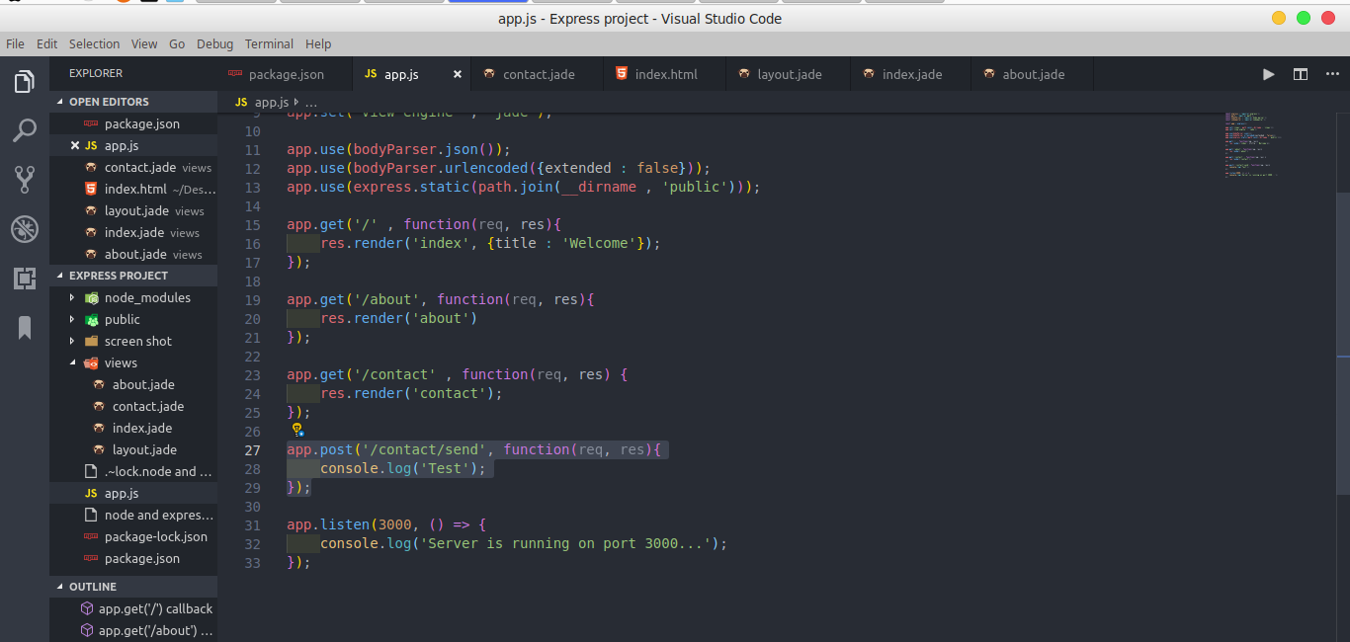
Output:

when we click on submit button test content store in console.

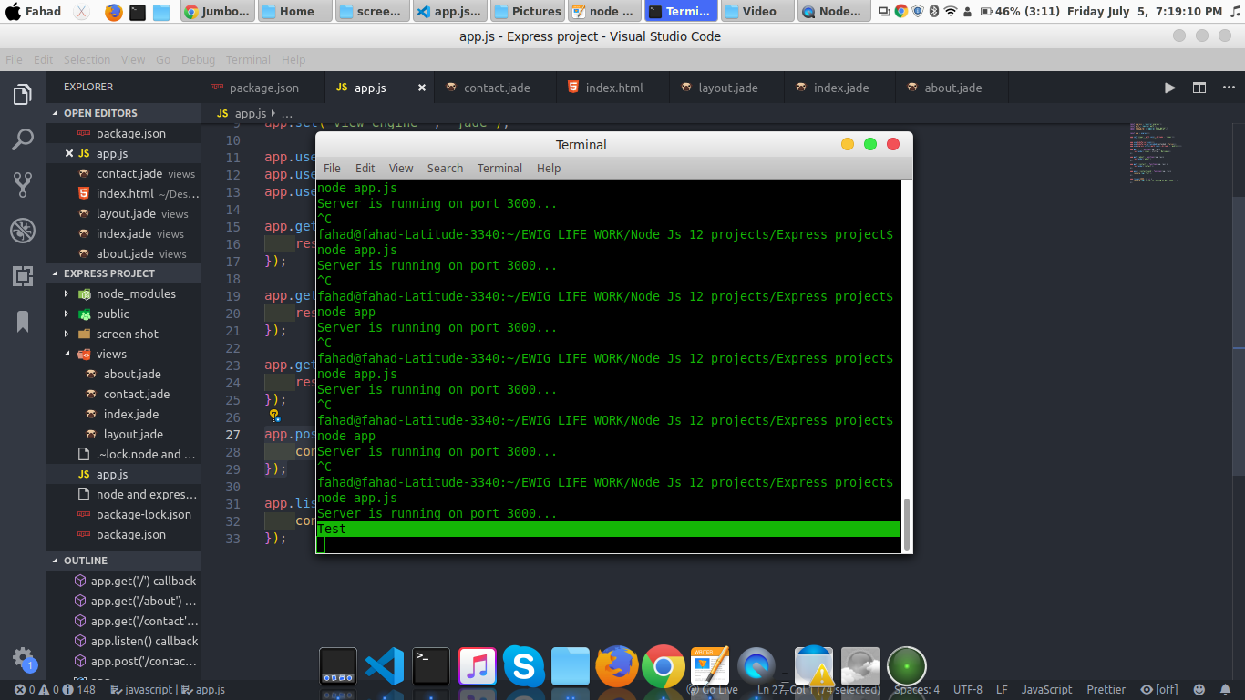

Now send Email using nodemailer.
Use your email and password here

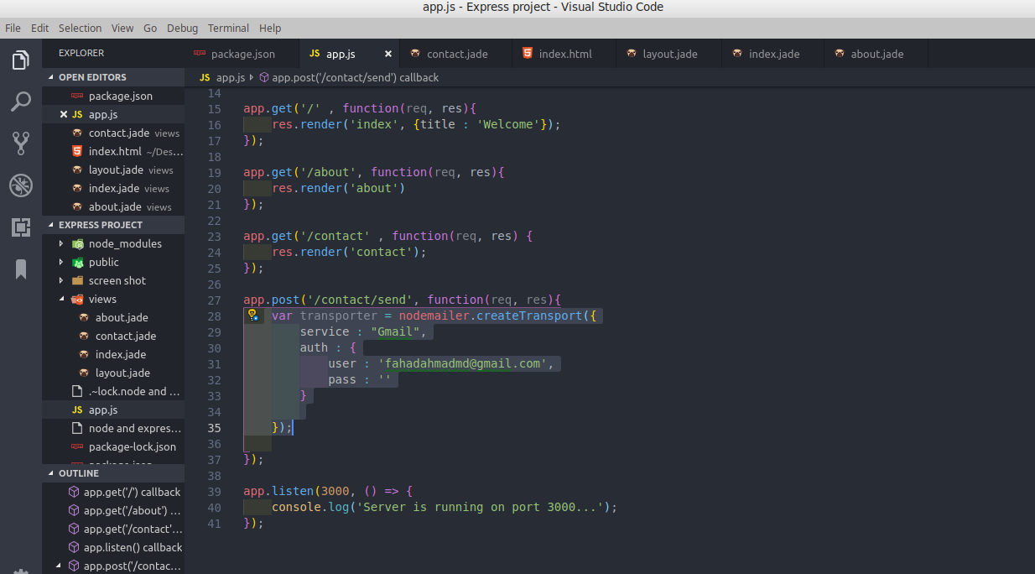
Create a variable and add sender and receiver email also define input filed name what you send.

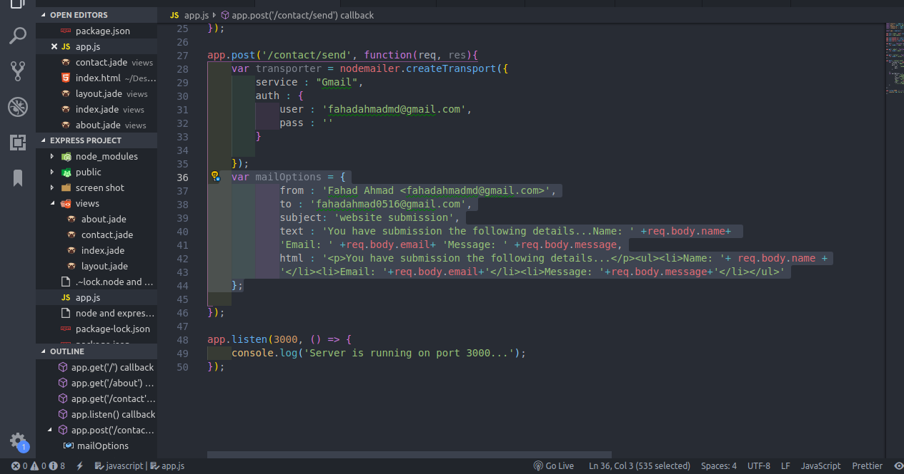

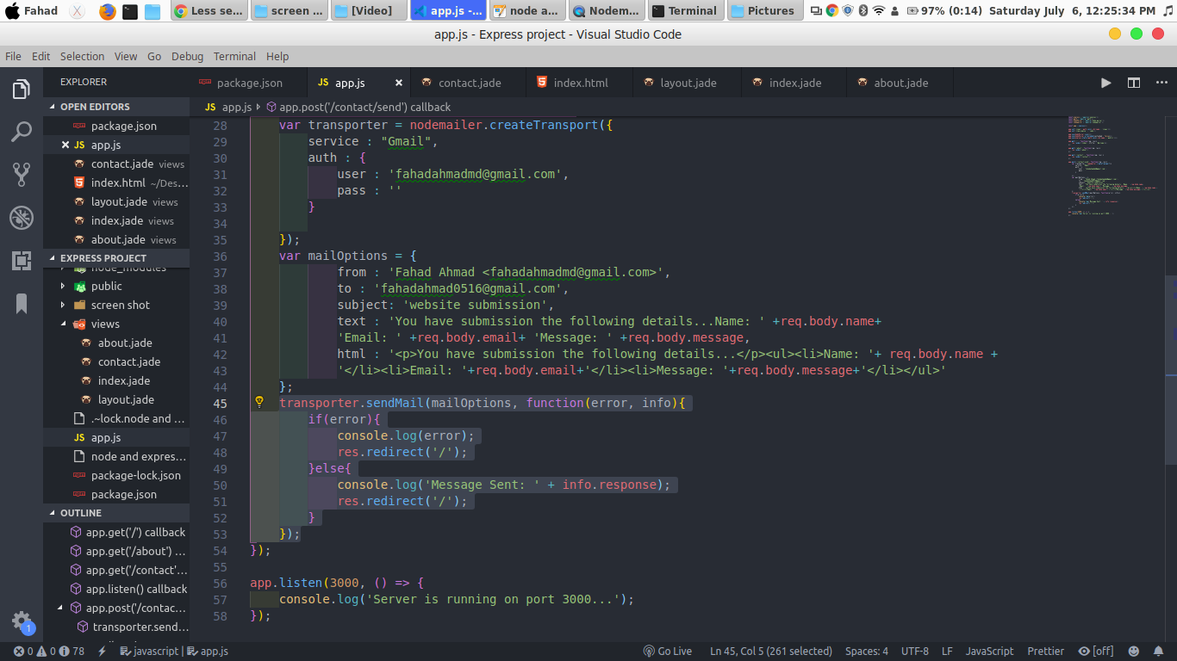
Now add if condition for redirect.

Now go google/lesssecureapps and Allow less secure app ON

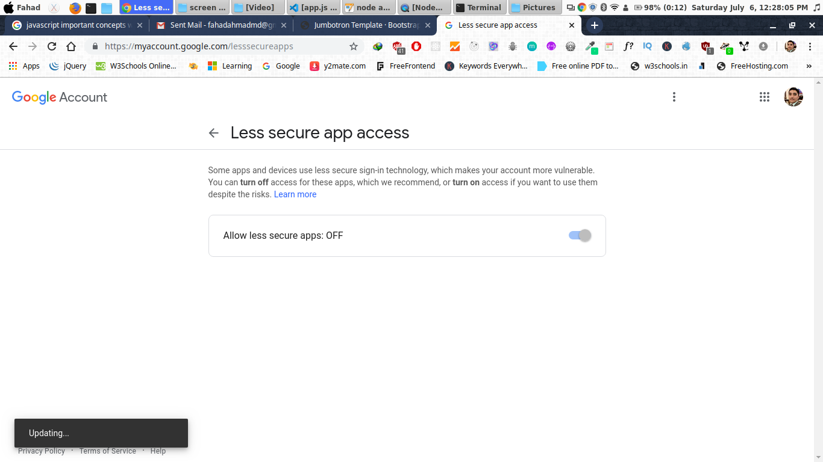
Now run server and enter data in input and submit.

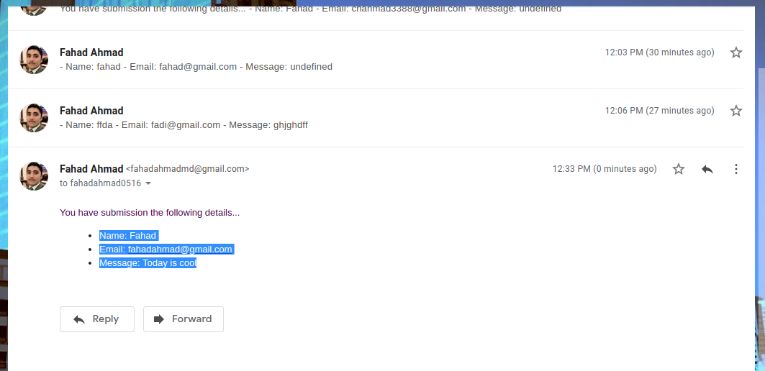

Project is Done...

